Name: M. Hassan Ahmed

Class: OS – LAB

Task: Lab 1-2

# Lab Activity 1:

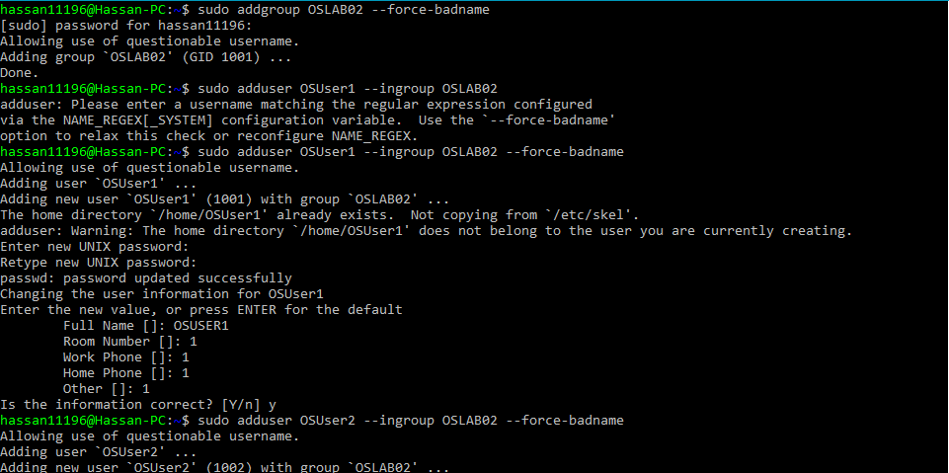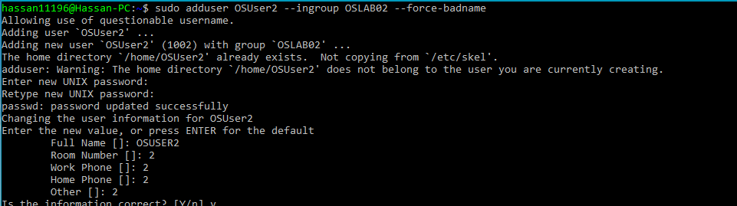

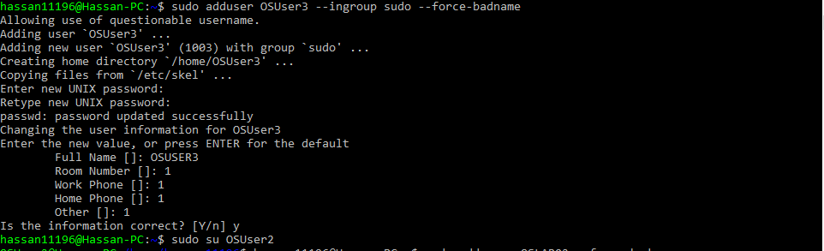

# LAB Activity 2:



# LAB Activity 3:

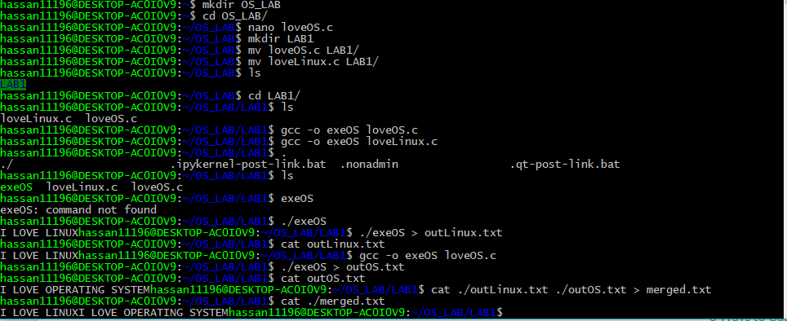

# LAB Activity 4:

A,b,c,d,e

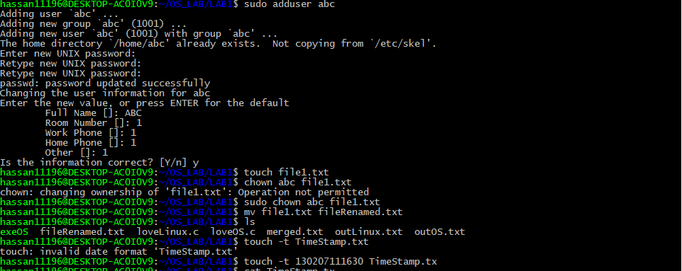

F

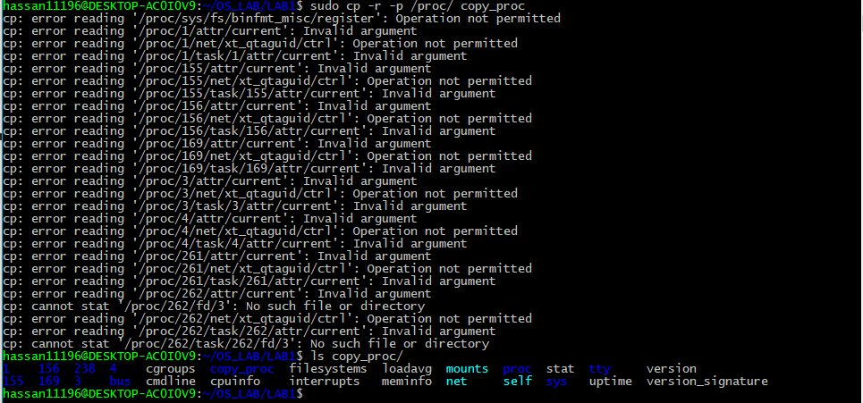

G



H

I

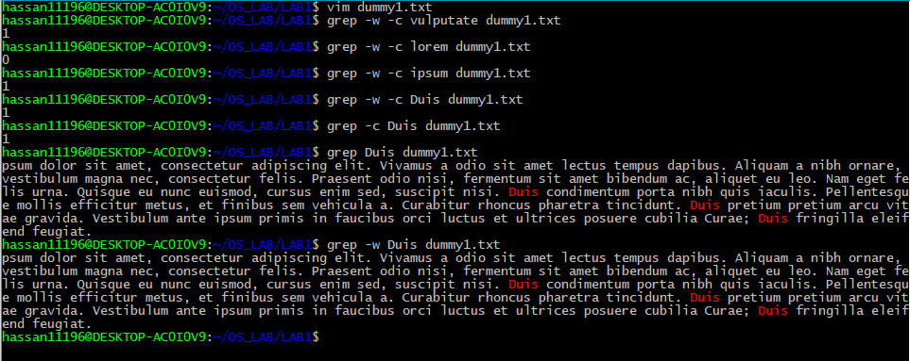

J



K

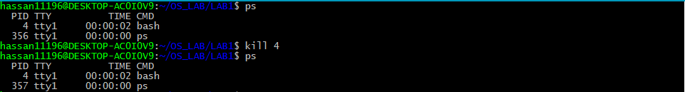

L



M

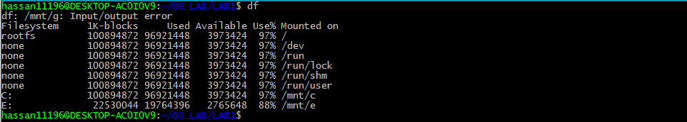

N

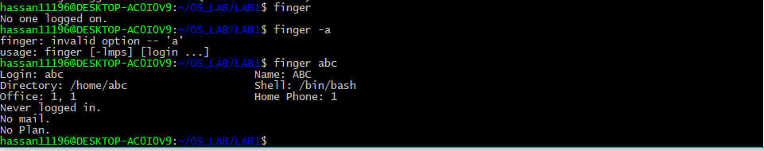

O

